Common Core State Standards (CCSS) Resources

Where to find the CCSS documents and Supporting Materials: California Department of Education
- “What are the Common Core Standards?”
http://www.cde.ca.gov/re/cc/tl/whatareccss.asp
Includes:
- A 3-min. video explaining the Common Core State Standards
- Links to the Math and English Language Arts Standards
- Appendices for Math and ELA

PTA’s Parent Guides to Success were developed by teachers, parents, and education experts in response to the Common Core State Standards.
http://www.pta.org/parents/content.cfm?ItemNumber=2583&navItemNumber=3363

Math:
Videos: Math in the Classroom

- Reasoning About Multiplication and Division (3rd grade)
https://www.teachingchannel.org/videos/multiplication-division-in-the-core

- Addition within 100: Strategy Sharing (1st grade)
https://www.teachingchannel.org/videos/grade-1-math

- Skip Counting with Counting Collections (Kindergarten)
https://www.teachingchannel.org/videos/skip-counting-with-kindergarteners

From www.youcubed.org
Jo Boaler, Mathematics Education Professor, Stanford University

- Why Students in the US Need Common Core Math
http://youcubed.org/parents/2014/why-we-need-common-core-math/#more-37

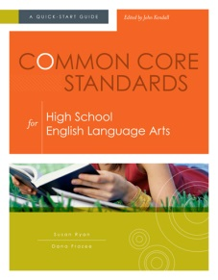
English Language Arts:

- From Common Core Standards for High School English Language Arts
Chapter One (a well-written overview of the ELA Standards and the most significant changes to common curricula)
http://www.ascd.org/publications/books/113010/chapters/About-the-Common-Core-English-Language-Arts-Standards-for-High-School.aspx

Videos: ELA in the Classroom

- Exploring Imagery through Beowulf (7th grade)
https://www.teachingchannel.org/videos/descriptive-details-sensory-language

- Post Its: Little Notes for Big Discussions (5th Grade)
https://www.teachingchannel.org/videos/enhance-student-note-taking

- Describing Character and Events in a Story (1st Grade)
https://www.engageny.org/resource/grade-1-ela-describe-a-character-and-events-a-story-rl13-rl-15

